The Challenge of Time in India’s Defence Capability and Capacity Building
Lieutenant General Vijay Singh (Retd)

Byline
The private sector R&D is in its nascent stage and is profit driven. While numerous government incentives are promoting research-oriented start-ups, ultimately, it is a profit and loss game that decides the future. At the same time, government-owned defence R&D and production institutions retain considerable scope for improvements in efficiency, accountability, and outcomes to fully realise the benefits of ongoing reforms.

India has embarked on the challenging endeavour of compressing developmental timelines for technological advancements and defence production capabilities to match and sustain modern-day battlefield requirements. Numerous collaborative efforts with tech-savvy nations like the USA, Russia, France, Israel, the Netherlands, the UK, Japan, South Korea, and others have been formalised. Correspondingly, in-house efforts are also underway through persistent financial incentivisation and policy changes in the public and private domains to drive production and core research and development (R&D). The results are encouraging; however, while the push at the highest levels is unswerving and emboldening, there are budgetary constraints, bureaucratic chains, profit-oriented private sectors, and limits to the levels at which other nations shall share technology. The catch-up game is not easy: translating strategies and policies into on-the-ground products demands a hard-nosed drive.

Research and Development
R&D in defence technology is driven by the Defence Research and Development Organisation (DRDO) in collaboration with specialised agencies, collaborative bodies, defence think tanks and associated strategic research-oriented agencies like the Indian Space Research Organisation (ISRO). Established in 1958, it has 45-plus laboratories, 5,000-plus scientists, and a support staff of 25,000; interestingly, some nation-states may not have a total of 5,000 scientists. Unfortunately, barring a few success stories, DRDO has not been optimal in its output. Its major achievements have been in the field of strategic missile systems, which ironically can be more attributed to ISRO, while other efforts, like Light Combat Aircraft (LCA), are yet to truly manifest.
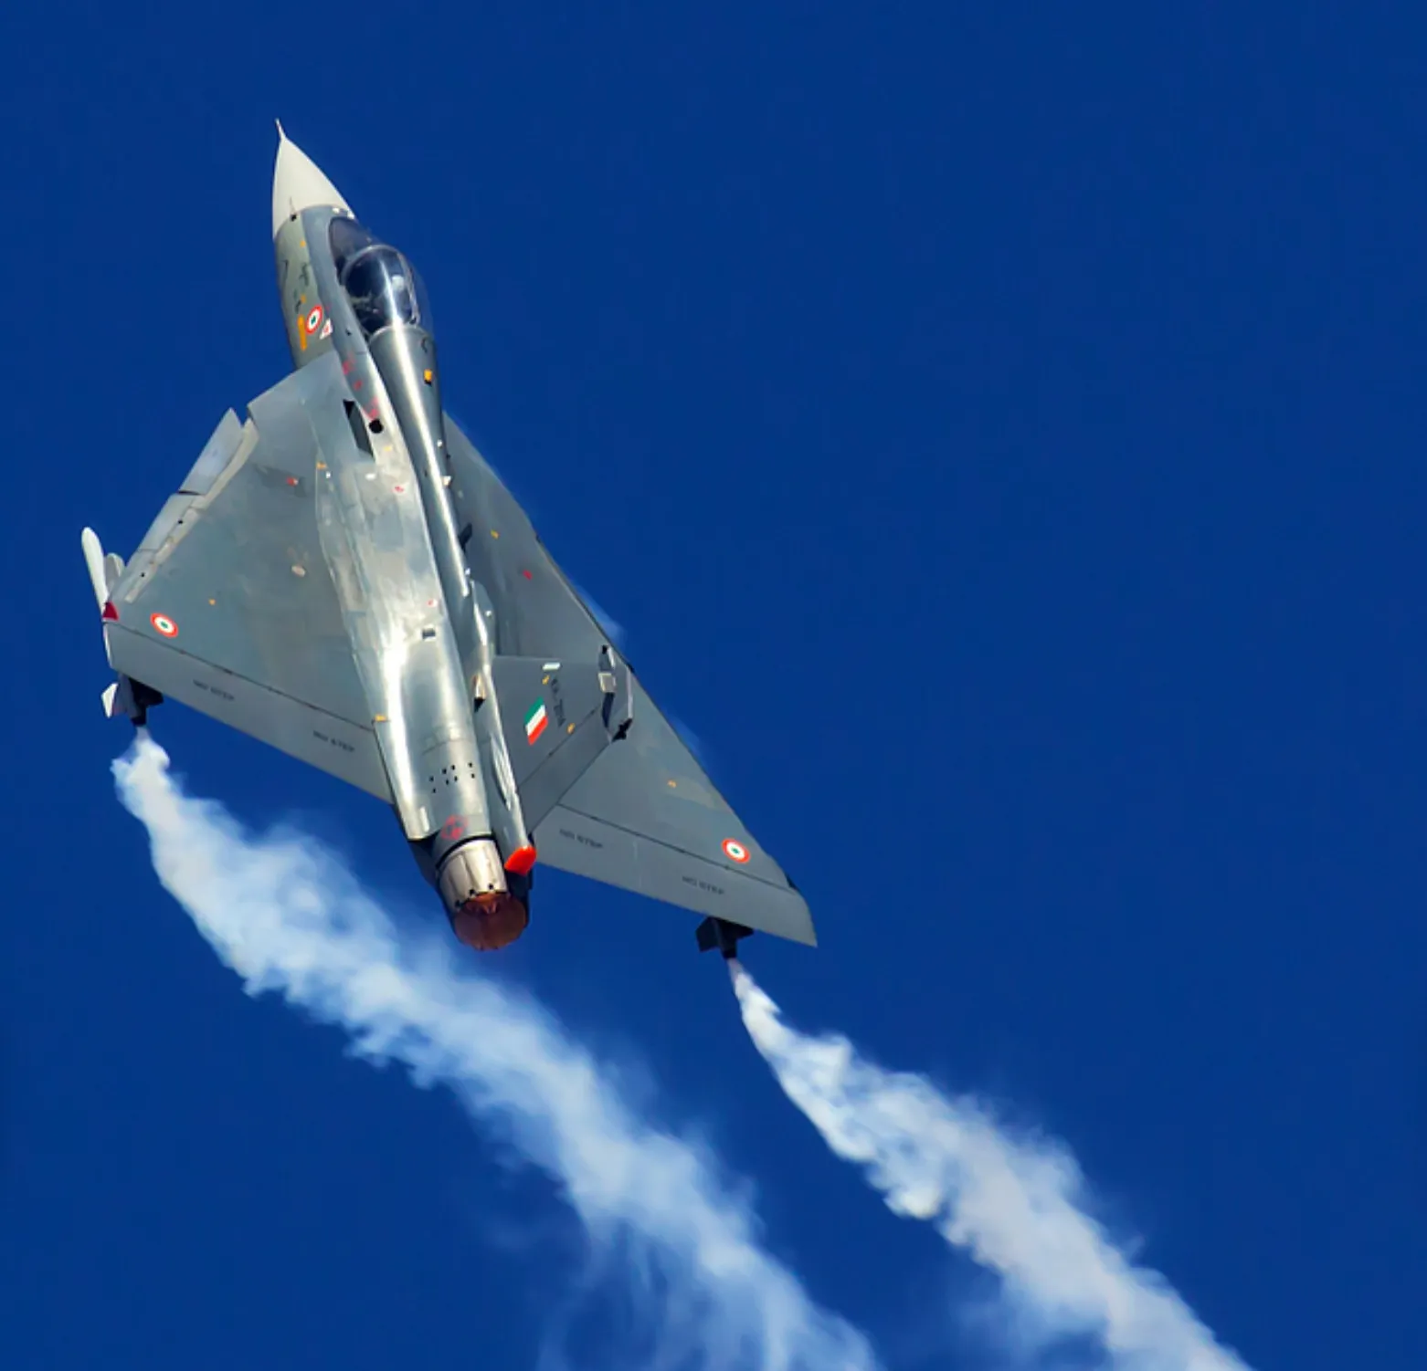LCA Tejas,
Source : flyajetfighter.com
The Parliament’s Thirty-Eighth Report of the Standing Committee on Defence, the Comptroller and Auditor General of India (CAG) feedback, and other inputs state the following on DRDO: Out of 178 Mission Mode (MM) projects, a staggering 119 fell in the delayed category. The delays ranged from 16 to 500%, and extensions were taken multiple times, leading to major cost overruns. Notably, there have been cases of project closures declaring them successful despite the non-achievement of one or more key objectives. Out of 86 projects declared as successful between January 2010 and December 2019, there are 20 projects where one or more key objectives or parameters were not achieved.
As per a Prime Minister's Office (PMO) initiated committee, while the project delays are attributed by DRDO to frequent user requirement changes, it is clear that at least 60 percent of the delays are due to DRDO’s internal structures and functioning. In July 2024, the said committee suggested reforms; however, surprisingly, the recommendations were labelled as contentious by vested parties within the Government. DRDO finally agreed to implement 60 percent of the suggested reforms, except that later, the implementation of the accepted structural reform was deferred due to opposition by senior DRDO officials. Lack of direct accountability of DRDO to the defence services is another Achilles’ heel. In comparison, the two of the world’s premier defence research and development organisations, namely DARPA of the USA and DDR&D of Israel, have produced niche technologies over the years and are worth emulating in approach and systems.

The Defense Advanced Research Projects Agency (DARPA) of the USA has barely 220 state employees and approximately 100 to 150 program managers distributed in six technical offices that oversee approximately 250 research and development programs. Each program is led by a program manager who is contracted based on the program selected from those presented by the innovators from within and outside the defence services. As a norm, every program at DARPA is required to be high-risk and high-payoff and is rigorously screened using the Heliometer Catechism method. A unique aspect of DARPA is that program managers are on a defined tour of duty, typically two years, renewable for another two years, with the end date printed on the badges worn (IDEX). The long list of achievements of DARPA includes pioneering the ARPANET that later evolved into the Internet, GPS, Big Dog, cyborg insects, Graphical User Interface (GUI) and Mouse, Onion Routing, Human Universal Load Carrier, SIRI or Cognitive Assistant that Learns and Organises (CALO), HAARP or the High Frequency Active Auroral Search Program, AI, and Stealth Technology.

Israel’s Directorate of Defence Research and Development (DDR&D), a joint MoD and IDF body, is a world-renowned research and development centre that needs no introduction. It is headed by a director, a serving brigadier general, who is appointed by the Ministry of Defence in coordination with the Chief of General Staff and the MoD Director General. He reports to the Director General on issues related to the responsibilities of the Ministry of Defence and to the IDF Chief of Staff on issues related to the military. This integration and cooperation produce exceptional results. Given its reputation, it is funded by various sources, including the USA, EU, and India through the India-Israel (14F) Strategic Call for Proposals with a maximum funding of 100,000 USD for each project for the Israeli side.

Surprisingly, DRDO follows the government policy on the reserved quota system in recruitment, including for the selection of scientists. On the other hand, ISRO, fortunately, has no reservation quotas in its core category of R&D. This is amply highlighted in the quality of work differential between ISRO and DRDO, as the former focuses on merit. The private sector R&D is in its nascent stage and is profit-driven. While numerous government incentives are promoting research-oriented start-ups, ultimately, it is a profit and loss game that decides the future. Overall technology generation as well as adoption leaves much to be desired: unless the best minds are attracted and provided for, the required levels of efficiency to compete will be difficult to reach. An appropriate mix and match of the US and Israeli defence research mechanisms is required to be adopted for meaningful gains.

Defence Production
A major drive is underway to make the defence production-related public and private sectors effectively collaborate and synchronise efforts for optimal gains while ensuring the financial stability of the private industry. The public sector includes 41 ordnance factories, which include 23 added post-independence, and has 80,000 employees: one of the world’s largest government-operated defence production organisations. The setup, now under the Directorate of Ordnance (Coordination and Services), has been grouped into seven new entities in a corporatised version for enhanced effectiveness, but is barely floating.
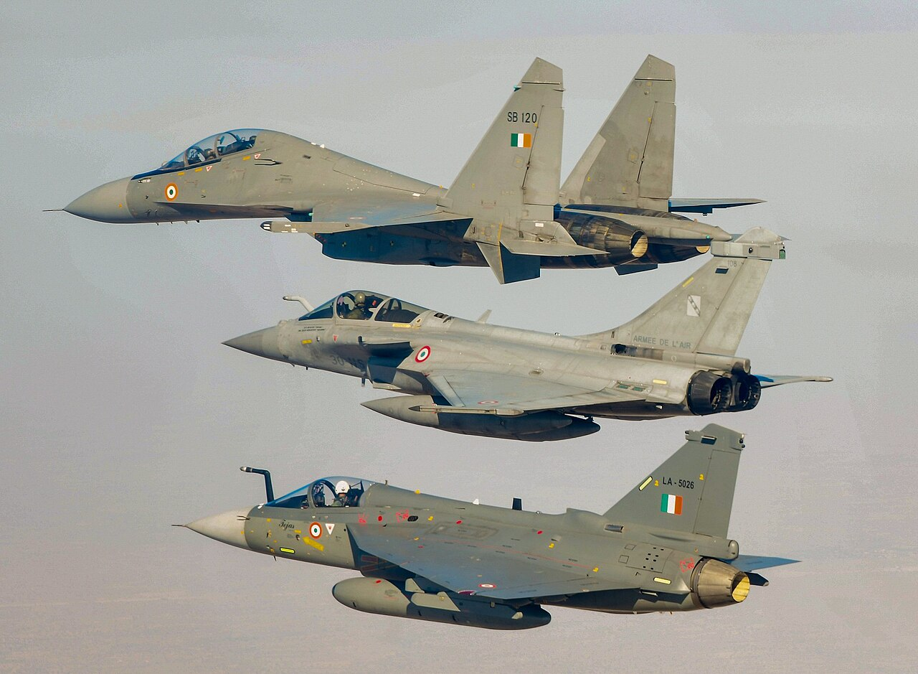
HAL Tejas, Dassault Rafale, Sukhoi Su-30 mki ;
Source : wikipedia.org
The Thirty-Eighth Report of the Standing Committee on Defence (2022-23: Seventeenth Lok Sabha) on the DOO (C&S) had two key observations. Firstly, the order book of these newly created Defence Public Sector Undertakings for the next five years suggests a steep decline, with some having no orders placed on them till 2028. Secondly, the indigenisation percentage claimed by DOO (C&S) to be at 94 to 100% is primarily limited to clothing and suchlike accessories. The avoidable inadequacies and the challenge of desired efficiency levels remain, despite the recent corrective measures. The hindrances can be attributed to various factors that are known, but their acceptability, especially amongst those responsible for running the system, is not forthcoming. Certain other areas need attention as well.
- As there is no pressure on public enterprise employees to perform. To highlight the aspect of output, a prominent private production house in the country involved in defence production, having a workforce of approximately 5000, had, in a financial year, a revenue generation of Rs 10,460 crores, an operating income of Rs 1250 crores, and a net income of Rs 1081.75 crores. In comparison, the factories under the DOO (C&S) posted a total profit of just Rs 1548 crores.
- Lack of competitive pricing vis-à-vis a private setup is not possible, given the overheads. Two of the seven new corporatised entities were placed in the ‘non-core activities’ classification, which implied that the armed forces were free to invite tenders from private players. It resulted in the private industry not only winning the contracts but also providing a better-quality product at less than half the price.
- Corporatisation has barely made a difference. Since 2021, the factories have been surviving by manufacturing to complete the three- to four-year-old backlog of demands of the defence services. The exports of arms and especially ammunition in recent times are more a function of the rise in demand in the wake of the ongoing extended conflicts and the time taken by the traditional international suppliers to reboot their manufacturing capabilities.
- DPSUs are managed by a hierarchy and a system that lacks adequate experience and expertise when compared to private setups. In China, the State-Owned Enterprises (SOEs) employ experienced corporate hands to run their setups. Recently, the state-owned generative AI firm, the Beijing Electronic and Digital Intelligence (BEDI), has appointed a former IBM executive as its Chief Technical Officer (CTO).
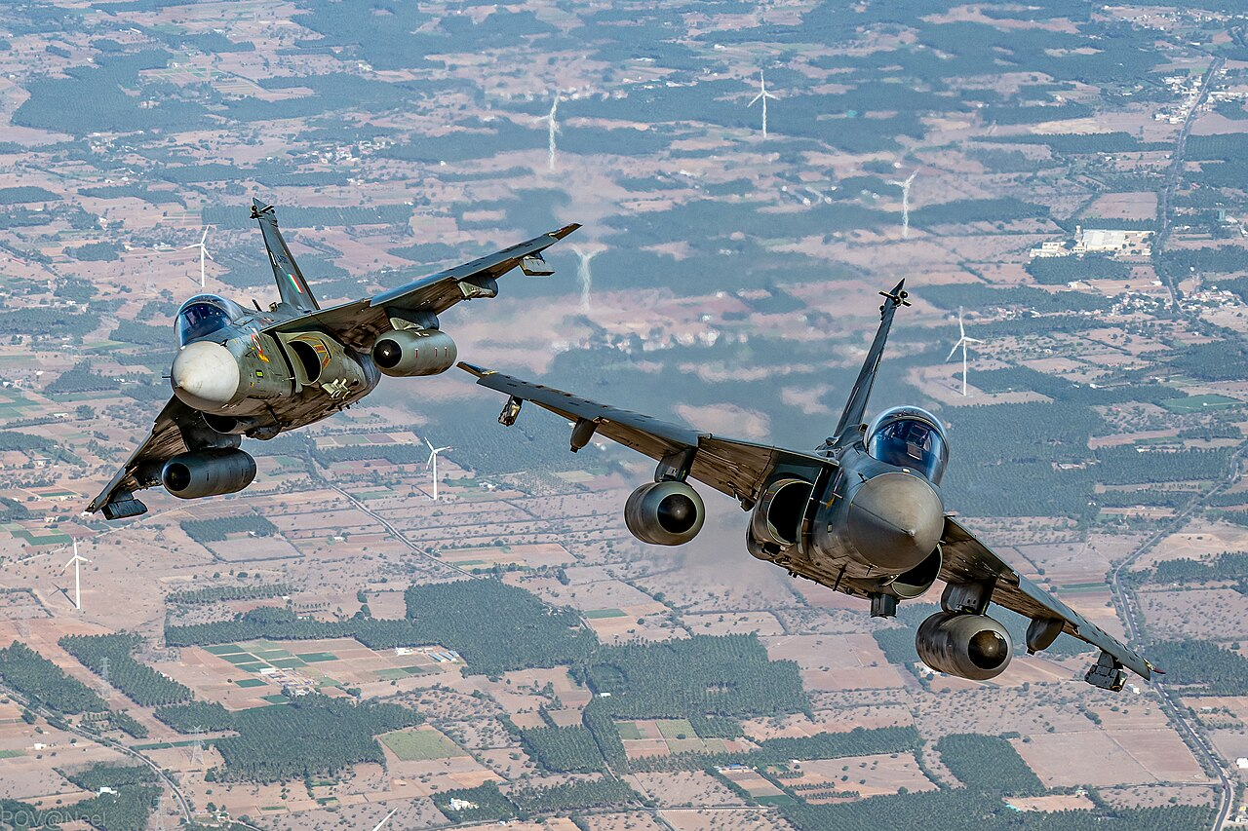HAL Tejas,
Source :wikipedia.org

The other PSUs are not at optimal output. The manufacturing of aircraft, submarines, ships, MBTS, and other big-ticket projects is delayed for lack of skills, procedures, and technologies. Unfortunately, the narrative building that suggests a phenomenal rise in technology and production capabilities is not helping in the right direction, besides giving an opportunity to non-performers to justify their existence or exploit funds. To state that Indian defence exports have surged to approximately $4.6 billion, which is a 25-fold increase, accounts for merely 0.2% of the global market share; a beginning, however, has been made. The private sector has an interest in defence research and production and is gradually gaining momentum; however, as mentioned earlier, private setups are profit-driven and demand a perpetual market that cannot be guaranteed given the unpredictability of war. State support in providing markets within and outside the country is essential.

Other Aspects
Raw material availability and management raise their own concerns: India today lacks materials required by the industry for manufacturing, which leads to heavy reliance on imports. Additionally, given the fact that the raw materials required by the high-end product manufacturers are nearly the same, there is no mechanism to ensure logic and requirement-based provisioning to each based on an overall strategy priorities. Limited availability of skilled manpower and machinery for the manufacturing of modern-day weapon systems is a hindrance. While modern machines can be procured initially, skilled manpower remains a challenge. The plethora of privately run technological institutes in the country lacks the drive and capabilities to produce the required technological skill sets.

Conclusion
The initiatives undertaken to promote self-reliance and the timelines defined to achieve these cannot be achieved with the current support measures unless a concerted, out-of-the-box, and integrated approach is adopted. The USA, in its National Defence Strategy (NDS) of 2022, states that it "will prioritise coordinated efforts with the full range of domestic and international partners in the defence ecosystem to fortify the defence industrial base." Further, the USA’s National Defence Industrial Strategy (NDIS) of 2023 emphasises the need “to coordinate and prioritise” actions to build a modern defence industrial ecosystem that is fully aligned with the NDS 2. It implies that unless a holistic approach is adopted for defence production and technology and the related ecosystem in both the micro and macroeconomic domains, the efforts being made shall not yield the desired results.

The recent policy initiatives taken are, firstly, inadequate to incentivise either the industry or the product users; secondly, the ease of doing business is still lost in bureaucratic translations: lack of understanding and drive is limited to publicity-oriented conventions and seminars. There is no dedicated or specialist staff in the administration: no restructuring of organisations has been undertaken. Flaws are in the boldness of initiatives, for the fear of imagined monetary or security repercussions, and the freedom for the industry to operate is choking. It may be a good idea to place the DRDO and the DOO (C&S) under the Chief of Defence Staff (CDS) instead of the Defence Secretary. There is also a dire need to break bureaucratic clutches and let the defence services be directly responsible for their requirements.

